# Overview

Project management is a global discipline that follows methodologies (aka, “recipes”) to provide advantages to an organization. Our Introduction to Project Management is a very small introduction. At Advisicon, we encourage all of our clients to do further reading or join a project management organization such as the Project Management Institute (PMI)®[1] to further their expertise in this area. You should do the same.

Project managers are often called upon to work as schedulers or to collaborate with others who perform the scheduling role. The practices in this book will ensure that individuals working in Microsoft Project 2013 and performing scheduling functions take advantage of the best features of Project. Before we take you through Project 2013, we will explore some of project management concepts this book is based on.

# Projects

Every organization has objectives to accomplish as part of doing business. Examples include creating marketing plans, developing products, gaining new customers, improving processes, and so on. When these company objectives are well defined and their results can be verified, a project is often created. A project consists of:

* A defined timeline including a start date and (often) a finish date target.
* A verifiable objective or goal that when accomplished signals the completion of the project.
* An application of company resources to help complete the project, such as a budget and resources.
* A dedicated manager to lead the project.

Projects are different from other company operations in that they are created for a specific objective and disbanded when that objective has been accomplished. Projects help focus organizational resources to accomplish an objective quickly and effectively.

When projects are discussed, they are often discussed in terms of the constraints on them. Project managers and schedulers have to negotiate for resources at specific points in time or negotiate for funding to purchase goods or services. The limitations on resources and funding are referred to as “constraints,” and can alter the speed at which a project is accomplished.

Constraints vary from project to project. On some projects, one constraint may be very tight, but the rest can give. On other projects you may be dealing with several tight constraints.

Still, every project has multiple possible constraints. Most specific constraints fall into one of five constraint types: budget, resources, time, quality, and scope. The level of sway each constraint has over a project determine the project’s shape.

Figure #.1 shows the shape of a project with a very tight resources constraint. In order to remain a feasible project, the other constraints have to be able to give.

A tight constraint forces some constraints to give more than others. In figure #.1, the time and scope constraints must be flexible in order to prevent the major constraint (resources) and the secondary constraints (budget and quality) from sinking the project.

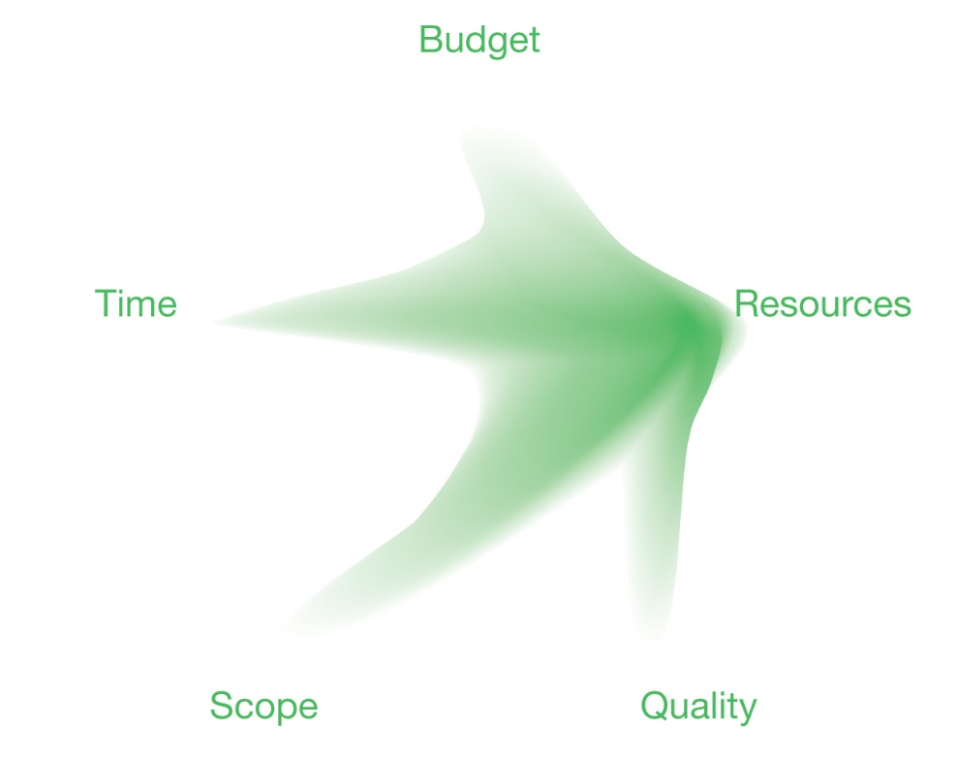

1. Illustration of Constraints on the Project [shape of project-constraints.ai]

A schedule is a model of a project. It describes the relationship of items needed to reach the project’s goal. Schedules also help manage the relationships between tasks and resources. Good communication is a critical aspect of successful projects and schedules are usually the means to do that. The benefits of scheduling and a more detailed explanation of Project 2013 are covered in Overview of Microsoft Project.

# Programs

Projects may be grouped into programs. A program is a collection of projects that are managed together because there is a benefit of doing so. Organizations assign a “program manager” to oversee the collection of projects while still giving individual project managers the authority to manage the work specific to their own project.

To better understand the difference between a project and a program, consider a magazine publisher who issues a new magazine every month. Each issue is a project with a timeline, a goal, and a project manager. The overall publication year, which consists of 12 issues, is managed as a program. This can help ensure that lessons learned from the creation of each issue are applied to future issues. The program manager can save money by negotiating resources for all 12 issues (e.g. paper, printing, distribution, etc.). Running a program is a good way to ensure consistency and delivery of the issues is optimized.

# Portfolios

If your organization participates in strategic goal setting and comes up with defined strategic objectives each year, portfolio management might be useful. Examples of strategic objectives include:

* Increasing market share
* Increasing repeat customer business
* Improving employee efficiency

A strategic objective is a goal for the entire company; one person and one project would not be enough to accomplish this goal. Your company may assign a portfolio manager to oversee several strategic objectives.

A portfolio consists of projects and programs which may or may not directly relate to each other, but which collectively support the strategic goal. A program which consists of projects focused on updating technology does not directly relate to a project which creates an employee cafeteria. However, managed as a portfolio, all of these projects support the strategic objective of improving employee efficiency.

For further reading on the topic of project management, refer to standards developed by PMI®[2]. These standards provide generally accepted concepts and principles but do not discuss project management software. The Project Management Institute, A Guide to the Project Management Body of Knowledge, (PMBOK® Guide) – Fifth Edition, Project Management Institute Inc, 2013 and The Practice Standard for Scheduling – Second Edition*[3]* are excellent compliments to this book.

# Project Management Processes

Project 2013 can be used to help manage projects, programs, and portfolios. To help drive success, organizations implement project management processes and lifecycle approaches when creating schedules. We discuss lifecycles in Task Development. A project management process is an approach that is standard across all schedules. It consists of high-level phases that are followed in an ordered pattern and phases may be repeated. An example of a process is:

1. Feasibility Study
2. Funding and Approval
3. Detailed Planning
4. Staffing
5. Execution and Delivery
6. Acceptance and Close-Out
7. Review and Analysis

Organizations use processes to ensure consistency and to train project managers and schedulers on business processes proven to successfully manage projects. Earlier phases can be repeated even if the project has moved onto later phases in the process. For example, it is feasible for ‘funding and approval’ to be repeated during ‘execution and delivery’ if an addition to the project requires additional funding for implementation. This will allow for an addition to the project to receive additional funding to help it be implemented.

If your organization does not have a project management process, we recommend you obtain a copy of the PMBOK® Guide and review the high-level process groups and the iterative nature of some of those groups. They are listed in order below for your convenience:

1. Initiating
2. Planning
3. Executing
4. Monitoring and Controlling
5. Closing

At Advisicon, we believe so strongly in the PMI recommendations that we are a Registered Education Provider for PMI. We will use PMI’s process groups as the project management foundation for this book. If you would like more information about these groups, refer to our book Practical Project Management.

# Project Server

Project is a software tool that can be part of an enterprise project or portfolio management system. Organizations looking for a portfolio management system may purchase and deploy Project Server. Advantages of Project Server include:

* Centralized resources in an enterprise resource pool provides insight into capacity across all projects.
* Consolidated project views in an online format provides information about schedule and budget status across all projects.
* User and group permissions enable a well-defined security approach to schedules by limiting access to portions of the schedule and limiting the ability to change information.
* Online access to project data provides the ability to use web browsers and handheld devices to view and update project information.
* Real-time information sharing and collaboration in an online format gives you the ability to make decisions using current and complete information.

Most features discussed in this book are also available in a Project Server environment. However, organizations have the option to implement security policies in Project Server which can eliminate or change the availability of features in Project.

The focus of this book is on Project desktop (Project Standard and Project Professional) features only. To use Project with Project Server, you have to ensure you have the appropriate version. Refer to the Project Desktop 2013 Overview of Versions in Overview of Microsoft Project for further details on features and versions. Project Server capabilities are discussed inour book, Microsoft Project Server 2013: Project Manager’s Guide.

# Key Points to Remember

We’ve provided some background on project management and gave you some information about how Project can support that need. We will dive further into the advantages of Project in Overview of Microsoft Project Supporting Project Management.

* Project management is a discipline that can help an organization receive benefits from their projects.
* A project is created to accomplish a specific objective and it is limited by constraints.
* A program is a collection of projects which have a related goal.
* A portfolio is a collection of projects and programs which have a strategic objective.
* A project management process may be used to guide projects through phases in an organized, repeatable manner. Throughout the process, an individual phase may be repeated if needed.
* An organization that uses Project Server will gain benefits of an enterprise project management system such as consolidated resource capacity, real-time project information, and defined security policies.

1. PMI is a registered mark of the Project Management Institute.
2. PMI is a registered mark of the Project Management Institute.
3. PMBOK Guide is a registered mark of the Project Management Institute.